**ASSIGNMENT 1:**

In this assignment we work on **“Superstore_Canada” dataset.The data contains a four tables with the following names : Orders,Returns,Target,Users.**

**To load dataset into tableau desktop:**

**Click** on **"New Data Source"** and select**"Microsoft Excel**" and navigate to the dataset folder.

**Task 1:- Create a summary table and format your numbers exactly like shown in screenshot below.**

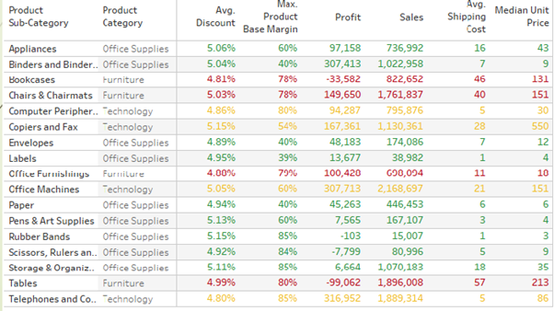

Step 1:Drag and drop "Product Sub-Category" dimension and "Product Category" dimension to Rows shelf.

Step 2:Drag and drop "Measure Names" generated dimension to Columns shelf.

Step 3: Drag and drop generated "Measure Values" on to Text icon under Marks card. Remove the unwanted green pills which are not intended to display under "Measure Values".

• Click on arrow icon of "SUM(Discount)" under Measure Values. Change the "Measure(Sum)" to Average option. Then click on arrow icon of "AVG(Discount)" under Measure Values and click on Format option. A pane "Format AVG(Discount)" gets displayed on to the left side.Now, under "Default" property of "Pane" Section, change the "Numbers" format to "Percentage" with Decimal places as 2.

•  Click on arrow icon of "SUM(Product Base Margin)" under Measure Values. Change the "Measure(Sum)" to Maximum option. Then again click on arrow icon of "MAX(Product Base Margin)" under Measure Values and click on Format option. A pane "Format MAX(Product Base Margin)" gets displayed on to the left side.Now, under "Default" property of "Pane" Section, change the "Numbers" format to "Percentage" with Decimal places as 0.

•   "SUM(Profit)" and "SUM(Sales)" are already in required format.

•  Click on arrow icon of "SUM(Shipping Cost)" under Measure Values. Change the "Measure(Sum)" to Average option.

•  Click on arrow icon of "SUM(Unit Price)" under Measure Values. Change the "Measure(Sum)" to Median option.

• Drag and drop "Product Category" on to Color icon under Marks card. Change the color format of the values for each product category as per the requirement.

**The resultant visual is shown below:**

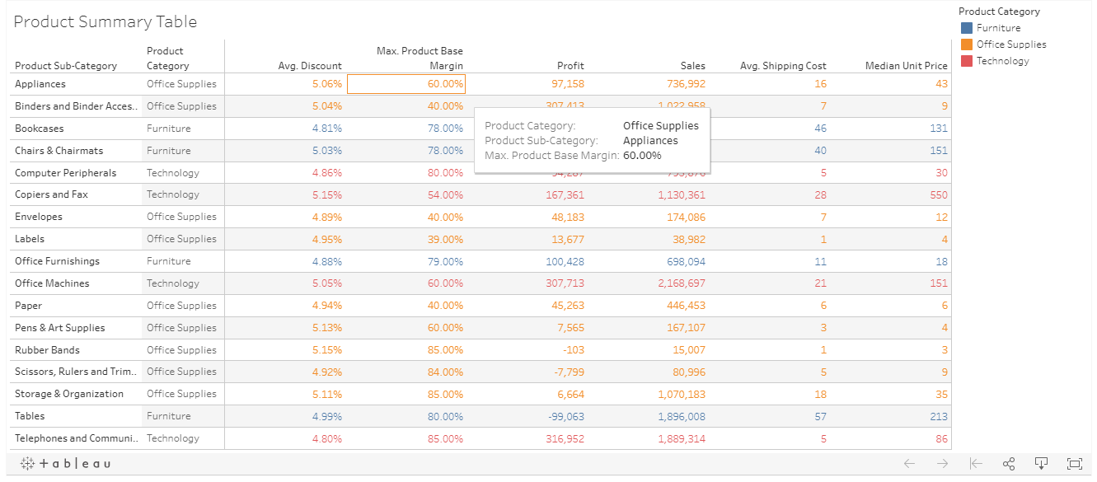

**Task 2:- Create a summary table and format your numbers exactly like shown in screenshot below.**

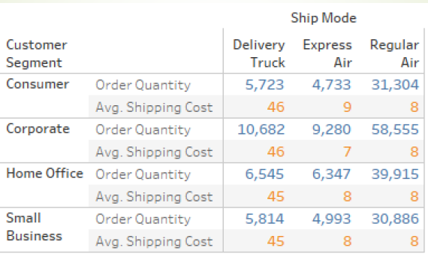

Step 1: Drag and drop "Ship Mode" dimension to Columns shelf.

Step 2: Drag and drop "Customer Segment" dimension and "Measure Names" to Rows shelf.

Step 3:Drag and drop "Measure Values" on to Text icon under Marks card.

Note: Remove the unwanted green pills which are not intended to display under "Measure Values". and keep only "SUM(Order Quantity)" and "SUM(Shipping Cost)" green pills under Measure Values

Step 4: Click on arrow icon of "SUM(Shipping Cost)" under Measure Values. Change the "Measure(Sum)" to Average option.

Step 5: Drag and drop "Measure Names" on to Color icon under Marks card.

**The resultant visual is shown below:**

